Getting Started / Developer rulebook

[Team] Setting up a new employee
- Create Google Workspace Account
- Set up user permissions in Workspace, Drive shared folders, Slack + channels, and anywhere else it is needed
- Send them welcome email / the get started guide link
- Confirm Employees have access to slack
- [Insert HR THINGS HERE]

[All Employees] Device Management & Setup
Change your password, use a secure password. Restrictions should be enforced.
You will receive a laptop which must be connected to the expanse vpn at all times.

Service Desk, IT, HR, Recruitment and friend referrals
Message Matt directly for now

Your Applications [Developers]
- Google Workspace Account including
  - Google Account + Gmail
  - Google Drive and shared drives depending on your and/or projects
  - Google Docs with live editing
  - Google Sheets, Google Meet, Google Calendar, etc.
  - Single Sign On / Account Federation - use your google account to log in to other applications
- Jira - Project management, status updates, sprints, roadmapping
- Slack - Communication, product updates, automated messaging
- Google Drive Shared Access - important documents
- Github - Expanse’s repositories
- VPN - Nord Layer ( company name “expanse” ) - Expanse Main Network
- Google Cloud Console - our servers, dns management, asset storage, automated deployment, databases, load balancers, and more

You can request access for these tools
- Adobe Creative Cloud Suite
  - Photoshop, Illustrator, Adobe Stock, etc
- Other as needed

Your Tasks
- Read the Expanse Company Manual for an informative overview of how expanse operates and what is expected of you.
- Review Payments and Processing
- Review Project management expectations
- Read Project Readme and Related documentation
- Review project files, modules, and code
- Review Wikis and Documentation as well as Slack Channels
- Read secure practices references and owasp documentation ( here )
- Read developer setup & coding guidelines
- Review Software Architecture
- You can find help getting set up with your project in this document
- zshrs script example and explanation
- Review technical documentation for technologies you will be utilizing including
- JavaScript
- React
- Graphql
- Sass
- Material UI
- Node.js
- TypeScript
- Etc

- Maybe project specific though
- Visual Studio Code

Project Management, Estimations, and Reserving / Claiming Tickets
Please read the company manual for full documentation.

Reserving Stories
Will eventually be done on expanse’s web application. For now you will be presented with options of tickets to choose from. Max of 3 reserved tickets, user stories, or other backlog items at one time. Work closely with the Product Manager to confirm the best path

Estimations
We want to hear your estimates! You will participate in estimating user stories and PBIs. There is a chance to verify that you agree with estimation before starting work on any particular story.

Development guidelines
Merge Request / Pull Requests
See Project Repository for merge request templates. Follow the steps in the templates.
Commits
See your project documentation
Packages / Dependencies
Do not add any dependencies without first asking. Do not add unnecessary dependencies.
Demo Data
See readme and project repositories

Updating Ticket Statuses
- To do / Backlog / Approved tickets
  - Work with your Product Manager to reserve and estimate tickets
- Reserved / Claimed tickets
  - Once a ticket has been claimed it is assigned to the developer who reserved the ticket. Work has not yet begun on tickets in the reserved / claimed state.
- In Progress tickets
  - Once you begin work on a ticket you need to move the ticket to in progress immediately
- In QA Testing Tickets
  - Once you are finished working on the ticket and you have verified that the ticket is working correctly in the development / testing environment you need to update the In QA Testing status and assign to the dedicated tester for your project
- In PO Validation
- Ready for Release
- Released

Communication expectations
- Availability
  - Some overlap with 9-5 M-F and attend mandatory recurring and non recurring meetings as needed
  - Must complete more than one story per 2 week basis.
    - Alternatively, 4 stories in 1 month
    - Alternatively, more intense requirements and levels of employment

- Respond To Emails
- Request Tickets through your Product Owner and the backlog
- Extended Leave
  - Employees should work with their product manager to reassign tickets if you are going to be out for an extended period of time, or if you have work that is at risk of not being completed in the allotted time.
- Out of Office / Absence
  - Mark your calendar when you are expected to be out of office. Ideally mark it a couple of weeks in advance, but also as needed for sick days and personal days or when things come up.
  - Please communicate your availability with your team, guild, and product manager as needed
- Actively communicate in standup and meetings as appropriate. Communicate when things are behind schedule. Respond to emails.
- Actively comment on Jira.
  - You are expected to update the status of your tickets and task/subtask as changes occur.
  - Tickets should be updated at least every few days, ideally tickets would be updated every working day. Even if the update is to comment and say there are no updates for the day.

MYSQL dev.mysql.com/download
Download and run the installer
Choose Developer default setup
Do not need to download python, or other extensions just choose continue

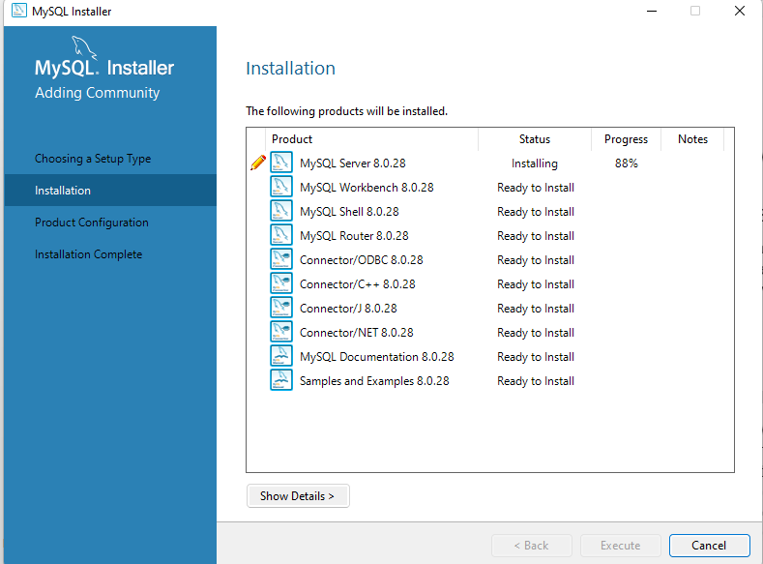
After all complete choose config type: development computer
Default configs
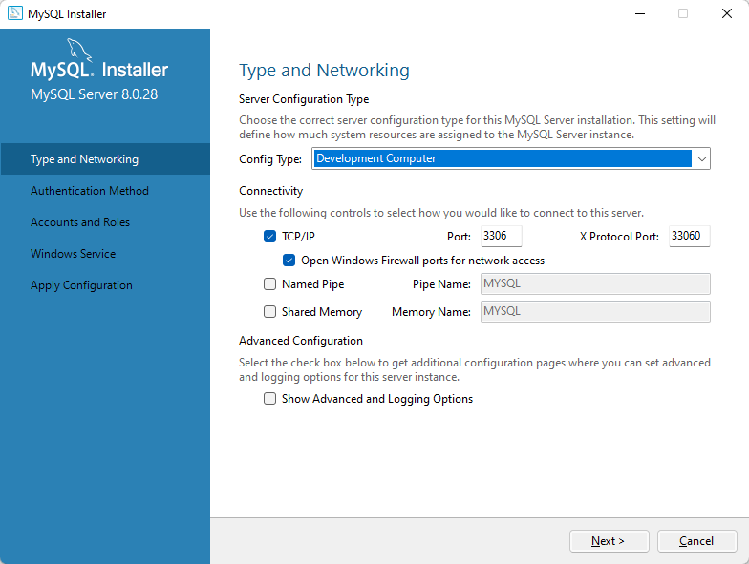

Choose Strong password configuration

Create a strong password for root user and continue with installation until finished
You do not need the mysql router

Mysql workbench is a tool for interacting with databases especially mysql and helps with db visualization of tables and relationships etc

